IET 600

Impact of Technology

American Social Contract

Due: 11/25/2012

By:
Jonathan Shane Wallingford
Abstract
The state of our nation is uncharted territory due to a vast shift in the mentality of the citizens in which reside in it now. People are out of work; new social programs are being created for healthcare, national debt is a staggering 16 trillion dollars and climbing every second, and the jobs that are available require special education and training. How do the people of this nation move forward and make the future livable?
This paper will examine the government’s role in education, healthcare, environment, safety and social service in the past and present to determine any trends that may predict what role the government will have in the future. Will the citizens of this country be less or more dependent on our government for things to make our lives more productive and safer or, will we gain the independent spirit that made this country an industrial giant of mass production using self reliance?
Research
To gain a better prospective as to how the government has morphed into the giant it is today, this paper will start in 1900 examining what the political mood of the times and people were. The United States was less than 40 years removed from the great Civil War and there were basically 3 titans that had emerged from the Industrial Revolution of the 1870 until 1900; John D. Rockefeller, Andrew Carnegie, and J.P. Morgan. (History, 2012) John Rockefeller controlled 90% of America’s oil refineries and therefore lit almost all of the lamps in America with Standard Oil’s kerosene. (shmoop.com,2012) Andrew Carnegie developed the steel industry to make bridges and buildings have larger spans and give America the infrastructure it needed to be an industrial giant. (History, topic, 2012)J.P. Morgan financed Thomas Edison and DC current to make the electric light bulb to form General Electric and eventually bargained or swindled (depending on perspective) Westinghouse and Tesla out of AC current to form the power grid we know today. These three men made up over 1% of the total GDP (Gross Domestic Product) of the United States at the turn of the century. (History.com) J.P. Morgan was so wealthy, in fact, that he lent as much as $300 million dollars in the late 1800’s. (History, 2012) Needless to say, if any of these three men did not want it to happen, it did not happen in the United States.
While these three men experienced wealth beyond imagination, 20% of working Americans living in northern American cities were at or below poverty. (jimgworld.com, 2012) Working conditions in the Big Three’s facility were terrible and pay was poor. At the dawn of a new century the desire for political change was growing in the United States. Many Americans believed that democracy could be improved, that politics could be freed from the grasp of the corrupt political machines and "bosses" that had controlled the major political parties for the last several decades. Special-interest groups emerged to lead reform movements at the city, state, and federal levels, but there was no cohesive, national agenda, no single source of reform. Reform groups ran the political and socio-economic gamut, as businessmen, unskilled workers, farmers, settlement-house workers, populists, socialists, and anarchists all worked for reform, and nearly every aspect of life was touched by their efforts. (Bookrags.com, 2012)
Starting in 1900, the federal government was small and had little to do with the ordinary man and everyday life. The government was not the tax giant that it is today by no means as spending was limited to $628 million for the fiscal year. (usgovernmentspending.com, 2012) Defense spending was 53% of that total bill, with no money being put forth for pensions, healthcare, and welfare. Take a look at the federal government spending in 1900 in Figure 1.
Function -yr 1900 +yr  Total Spending $628.6 million nom  Pensions $0.0 million nom  Health Care $0.0 million nom  Education $0.0 million nom  Defense $331.6 million nom  Welfare $0.0 million nom  Spending: actual | 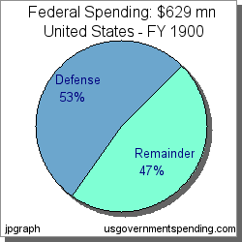

Figure 1 (usgovernmentspending.com, 2012)

The population of the United States in 1900 was 76,094,000 (demographia.com, 2012) and the number of people at or below poverty levels of the times were staggering. For the whole nation, a 1969 economics dissertation using Bureau of Labor Statistics studies, the manufacturing census, and other sources estimated that poverty among wage earners fell from 62 percent in 1870 to 39 percent in 1900, before rising to 44 percent in 1909. (sp2.upenn.edu, 2012) This was a considered a direct result of corporate greed and a lack of laws to prevent corporations of doing whatever they wanted to whoever they wanted at whatever the cost to people that worked for corporations doing the practices.
So, the table was set for the intervention for social reform for the population. The political mood had finally gave way enough that by the time President McKinley was shot and Theodore Roosevelt assumed power in the office, change for “Progressivism” had began. It was time for America to right the injustices brought forth to the mass population by what was considered the “establishment”, and make social reform a part of government. As with any cause, it would not come cheap or without end. Examining the chart in Figure 2 will show how the social reform that began in the early 1900’s has escalated into a spending frenzy today.
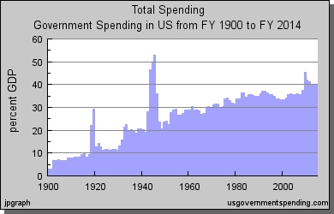
Figure 2 (americanthinker.com, 2012)
Upon examination, one can see that in 1900 the United States government spent about 6% of the GDP. The two (2) spikes that are present in the graph are the two (2) World Wars. Taking out the spikes in the graphs for conflict and war, examination shows a steady incline of spending on the government’s part to about 40% today. Now, in this examination one must have the understanding that the population of the United States is far larger now than in 1900, approximately 76,000,000 to 313 million today (usnews.com, 2012) respectively, about 4 to 1 larger. This means that there are more people making more money and more businesses making more money, which in turn gives a much higher GDP. The government spent 6% of the total GDP in 1900 and the GDP in 1900 was $545 billion (manyeyes.com, 2012). The government now spends 40% of the GDP and the GDP in 2007 was $14 trillion. (Futuretimeline.com, 2012) These can be viewed in Figure 3 below.
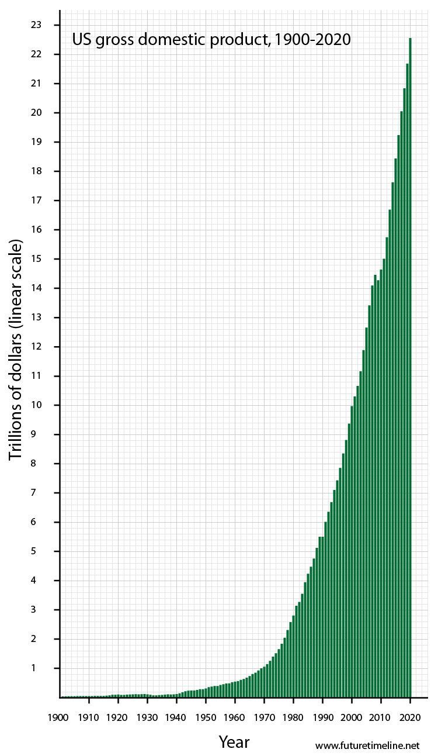
Figure 3 (Futuretimeline.com, 2012)
What about the national debt in all of this increased spending? Surely with the exorbitant of spending that has compounded over the last 100 years and the dramatic increase in the GDP, the nation is debt free now and there is no need for deficit spending as a nation. The country has the infrastructure and technology in place as an industrial giant to manufacture anything and everything, a people that is willing and able to work to provide the manpower necessary to perform the process needs, so the nation is primed for an era not seen since Andrew Jackson’s administration being a debt free nation. An examination of the next 2 graphs paints a very different picture that what is hoped for.
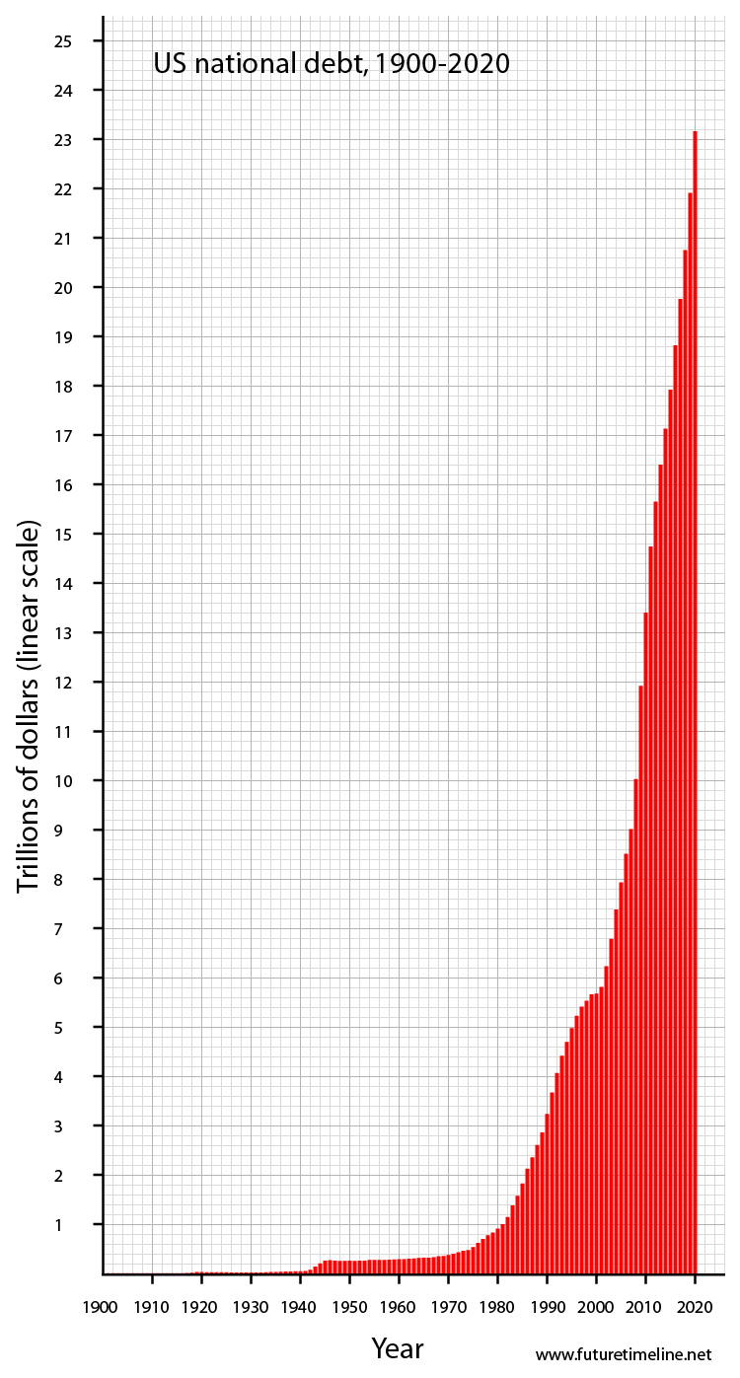Figure 4 (Futuretimeline.com, 2012)
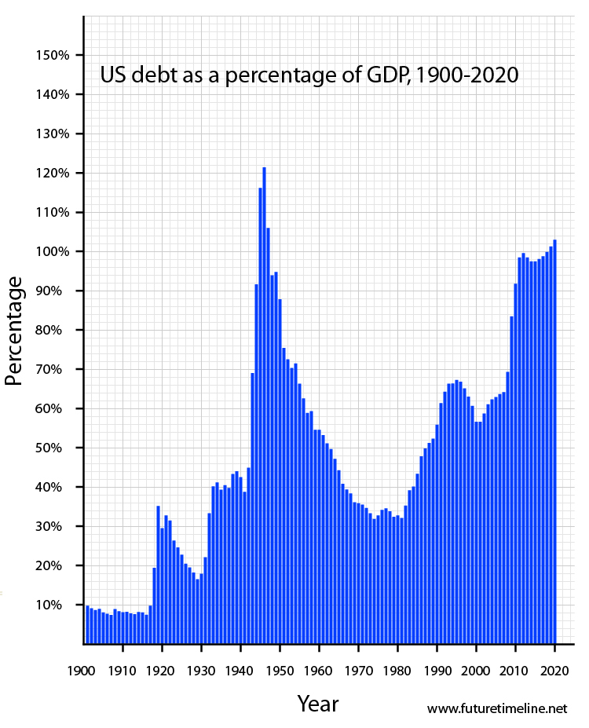Figure 5 (Futuretimeline.com, 2012)
These are mind numbing graphs to say the least. The United States national debt according to Figure 4 as of 2012 is $16 trillion dollars up from a trillion dollars in 1980 and about $500 billion in 1960. The worst point to all of this is the mindset of the government and how little attention they pay to it. In 1900, the government amount of debt per the GDP was 10%. Now, the national debt is better than 100% of the GDP. This all means that the government spends more than it is worth now.
So where is all of this money going? Why does the government spend so much and what do they spend it on? What has changed in the last 110 years in the government’s role in our life to justify the abundance of money being spent, and where do we see the future taking us in that light? The answer lies in social programs and the staggering effects it has had on our government.
If a review of Figure 1 is done, then one will see that there was no welfare, no pensions, and no education assistance in the government’s budget. In 1902 governments in the United States spent very little on relief of the poor, including less than 0.2 percent on relief and 0.25 percent on health care services. In the early 21st century, governments spend over 8 percent of GDP on welfare programs, including health care for the poor. (usgovernmentspending.com, 2012) The chart key below is a guideline to what the information in Figure 6 is.
Chart Key:
- Transfer to state and local
- Federal direct spending
- State direct spending
- Local direct spending
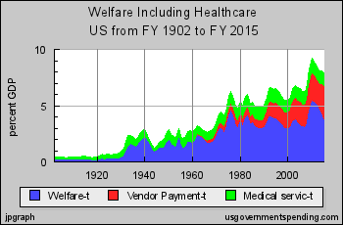
Figure 6 (usgovernmentspending.com, 2012)

To break this down even further, Figure 7 shows that the government spends nearly 3% of the GDP on Medicaid and other health services for the poor alone.
Chart Key:
- Transfer to state and local
- Federal direct spending
- State direct spending
- Local direct spending
Figure 7 (usgovernmentspending.com, 2012)
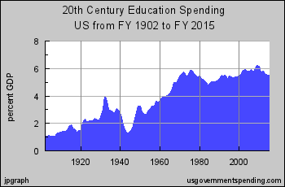
Figure 8 (usgoveernmentspending.com, 2012)
Figure 8 shows the increased spending in education since 1900 as part of the GDP. The figure shows that it is now about 6% of the GDP but maintaining at that point for now.
The most surprising chart of all of this is the pensions of federal employees. A review of Figure 9 is certainly mind boggling.
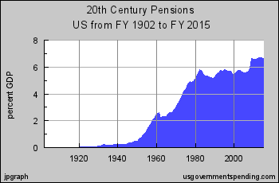
Figure 9 (usgovernmentspending.com, 2012)
One can easily see that pensions for federal employees did not start until the 1920’s and in less than 100 years, the government has fixed itself a nice little retirement plan to the tune of 7% of the GDP. That is unreal and government at its finest.
The environment is of great concern today. Government agencies such as the Environmental Protection Agency (EPA) have gained ground in getting laws implemented to help protect the environment. Born in the wake of elevated concern about environmental pollution, EPA was established on December 2, 1970 to consolidate in one agency a variety of federal research, monitoring, standard-setting and enforcement activities to ensure environmental protection. Since its inception, EPA has been working for a cleaner, healthier environment for the American people. (EPA, 2012) This is a very noteworthy cause for an industrial nation that in the early days put profits before general welfare of people in the area of the facility and paid little attention to the possible harmful effects of emissions. The problem may be that we have gone too far with this and business is unable to be profitable and cannot meet the requirements set forth in new legislation.
 | Government Pensions | 7% GDP
 | Government Health Care | + 7% GDP
 | Government Education | + 6% GDP
 | National Defense | + 6% GDP
 | Government Welfare | + 3% GDP
 | All Other Spending | + 10% GDP
 | Total Government Spending | 39% GDP
 | Federal Deficit | + 6% GDP
Figure 10 (usgovernemtspending.com, 2012)
If examination is completed on Figure 10 on the breakdown of the government’s spending habits and what the tax dollars got to, there is some interesting information to digest. Remember that the GDP is what the economy is doing and how much money the country is worth. Remember as well that the government owes more than our GDP actually is; the national debt is $16 trillion dollars and the GDP is around $14 trillion. (Figures 3 and 4)
The government spends 16% of the GDP right now on education, healthcare, and welfare which equates to about 2.5 trillion dollars. If the pensions for government employees are added to the total spending, then that number jumps to 3.22 trillion dollars. Excluding the defense budgeted monies, all other federal agencies are funded by 10% of the GDP or 1.4 trillion dollars.
Conclusion
The conclusion that this paper draws is the cuts are going to have to begin and the tax revenue is going to have to increase. Everyone is going to feel the pain and the cuts in government benefits. The ideas of government spending are going to have to change to a middle ground so that the budget is balanced and spending as a percentage of the GDP is normalized to an attainable level.
Education is going to have to be earned by the student. The students are going to have to work their way through school and employers are going to have to educate their workers through internships and education reimbursements. Students in high school need to prepare for their college life and try and make as good as grades as they can. Study for the ACT or SAT and get scholarships instead of giving half an effort to just get by and do the minimum. The role of the government is going to have to decrease in the role of providing the sole means of payment for higher education. The government may be able to offer assistance in a form of repayment means, with or without interest, but the days of a free education by the government is going to have to lessen. The criteria are going to have to be changed dramatically.
The welfare benefit is going to have to be minimized to include people that are unable to work. The government has done everything possible for the last 50 years to stop poverty to no avail. What the people have before them now is an abused system that is draining the tax dollar from the government. Welfare beneficiaries are not going to be able to have a cell phone paid for by the government; they are not going be able to have free healthcare and free government housing. People are going to have to work their way up from a ditch digging job to an equipment operator to a foreman. Society can no longer fit the bill for the people unwilling to help themselves. People are going to have to earn their benefit just as the people that have worked for 40 years and paid into Social Security retirement have.
The free medicine and the visits to the doctor for a sniffle have to stop as well. Elderly people that have worked their lives away to build this country in to what it is today should not have to sacrifice yet more than they have already. The people that have become a part of a system are the ones that must go without. The idea of being poor and all the misery that goes with it has to be there in order to drive people to have a better life with more luxury. The poor do not experience this today in the U.S. as much as third world countries and it shows. If the government keeps giving handouts that are not earned, then where is the motivation to try and improve on what potential lies out there for the people?
The little people are not the only that have to sacrifice. Doctors and hospitals have made fortunes for their services for the past 3 decades from government insurance for Medicaid and Medicare. They are now going to have to come off of that pricing. The flip side is the ability for someone to sue a doctor or a hospital for trimming a hang nail to close must stop as well. Colleges and Universities are going to have to cut back on tuition rates and book prices to make things a little more affordable. The idea of becoming a millionaire for services rendered for government payments must come to a halt.
The most important thing that has to go is government pensions for Congress persons and high level federal employees. If a person making $100,000 a year can’t make their own retirement while living for free, meaning that all of their expenses are paid for while in Congress or fulfilling their government duties, then something is wrong. This paper is not talking about cutting post office workers and others that make living working for the government; this paper is talking about those who make a fortune for public service for the government.
This country has gotten to be unfriendly toward business with new, hard to hit regulations. The infrastructure that is in place must be utilized for the fossil fuels and EPA regulations on emissions must lighten up. Society must realize that energy usage is a marathon not a sprint and work toward energy independence and clean energy. Society cannot afford to stop using these minerals now, but society must not forget that the goal is clean energy.
Society and technology as well as industrialist and educators must all work together with a common sense approach to solve the issues facing this generation of people. The blame game must stop and government reliance must cease in order for our country to move forward and be the reliable entity it has been for the last 200 years.
However, it is this papers opinion that none of the politicians in Washington D.C. will make the difficult choices necessary to make any of this happens. This government is no longer for the people, by the people, but rather for a few people by a few people. Tax drains such as government pensions, welfare, and free healthcare for those that will not or cannot pay for them will increase by 2025 if the government does not default before then. This paper feels that it will take a complete default in the monetary system and a complete bankruptcy status as seen it Europe for the reality to hit home and this to all come to an end. Unfortunately, it will cost the people trying to fight the waste in spending their country.

References

- Retrieved, 2012, video clip History Channel (The Men Who Built America)

- Retrieved, 2012, from website
http://www.bookrags.com/history/america-1900s-government-and-politics/

- Retrieved, 2012, from website http://www.usgovernmentspending.com/total_spending_1900USrn

- Retrieved, 2012, from website
http://www.demographia.com/db-uspop1900.htm

- Retrieved, 2012, from website
http://www.sp2.upenn.edu/america2000/wp7all.pdf

- Retrieved, 2012, from website http://www.google.com/imgres?imgurl=http://www.americanthinker.com

- Retrieved, 2012, from website
http://www.usnews.com

- Retrieved, 2012, from website
http://www.futuretimeline.net

- Retrieved, 2012, from website
http://www-958.ibm.com/software/data/cognos/manyeyes/visualizations/us-gdp-1900-2008

- Retrieved, 2012, from website
http://www.shmoop.com/gilded-age/economy.html

- Retrieved, 2012, from website
http://www.history.com/topics

- Retrieved, 2012, from website
http://jimgworld.com/pov101.html

- Retrieved, 2012, from website
http://www.epa.gov/history/

